Error Detection and
Correction

Error Control
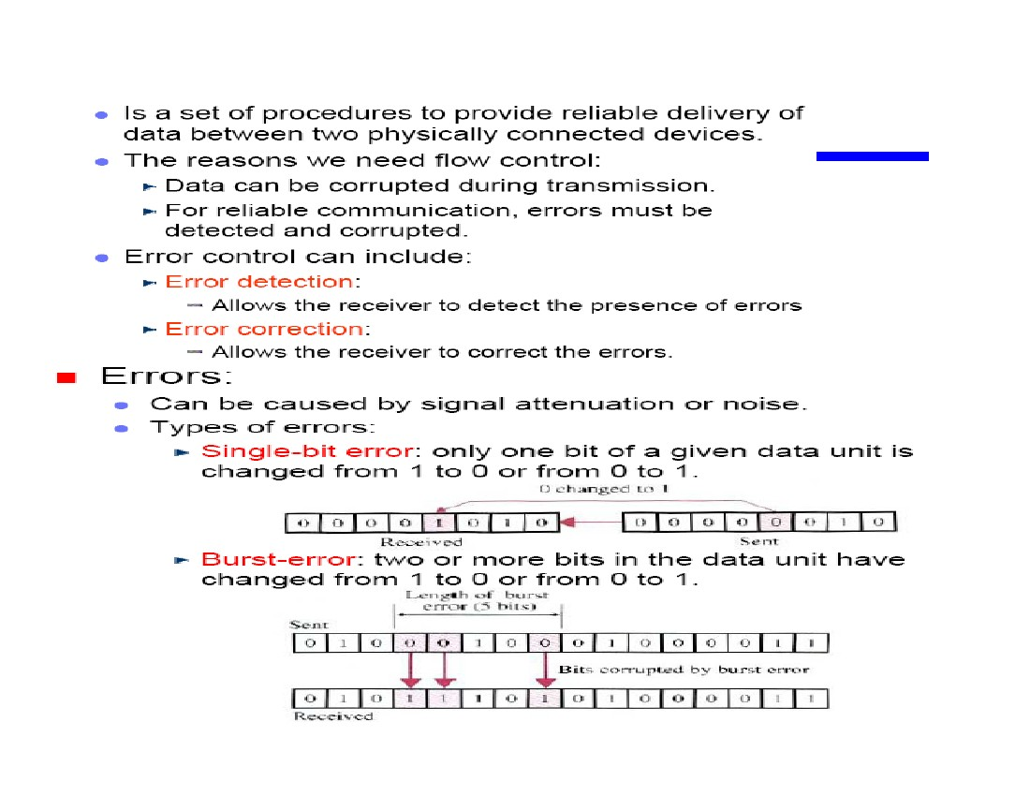
Error Detection
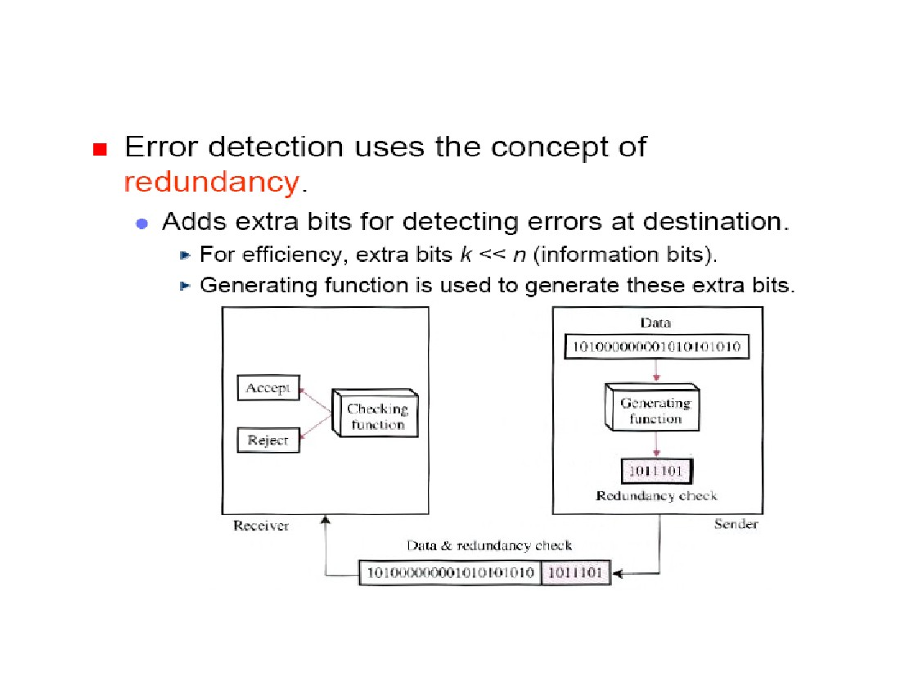
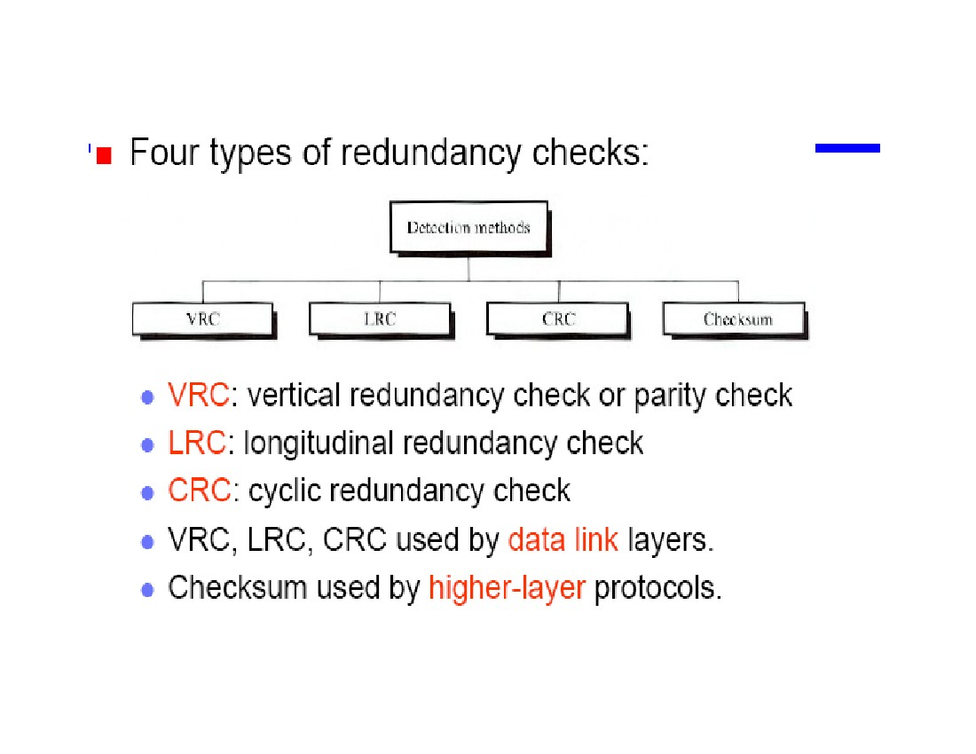
Error Detection
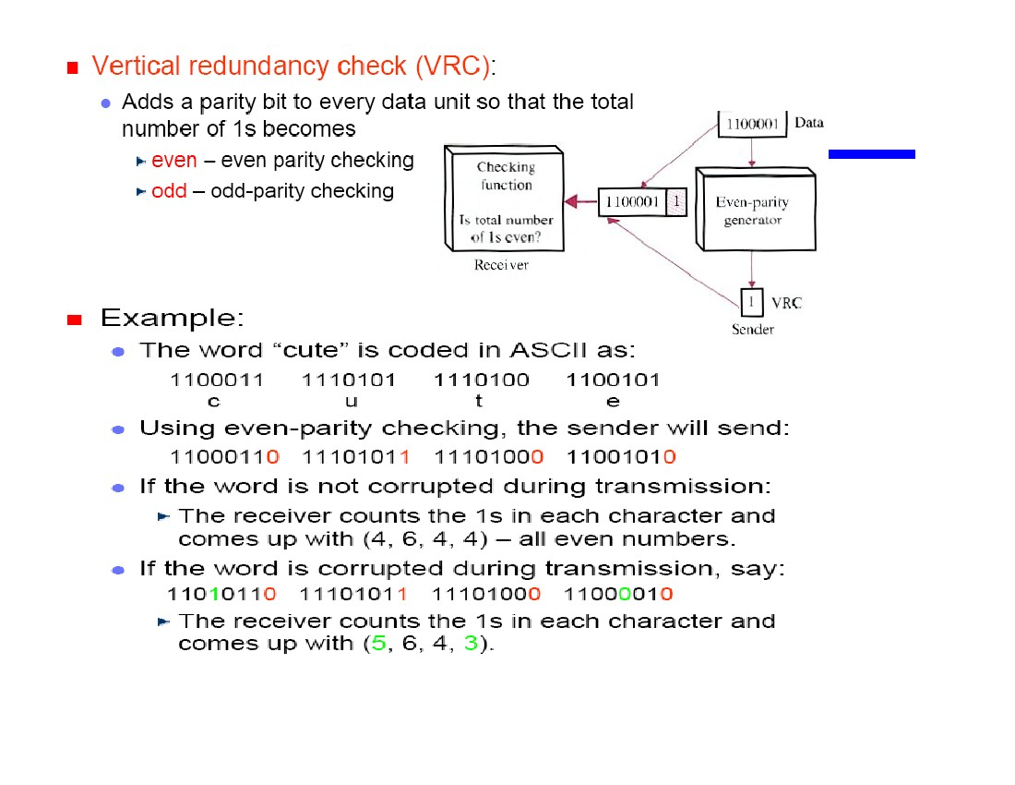
Can detect all single-bit errors.Can detect burst errors only if the total
number of errors in each data unit is odd.
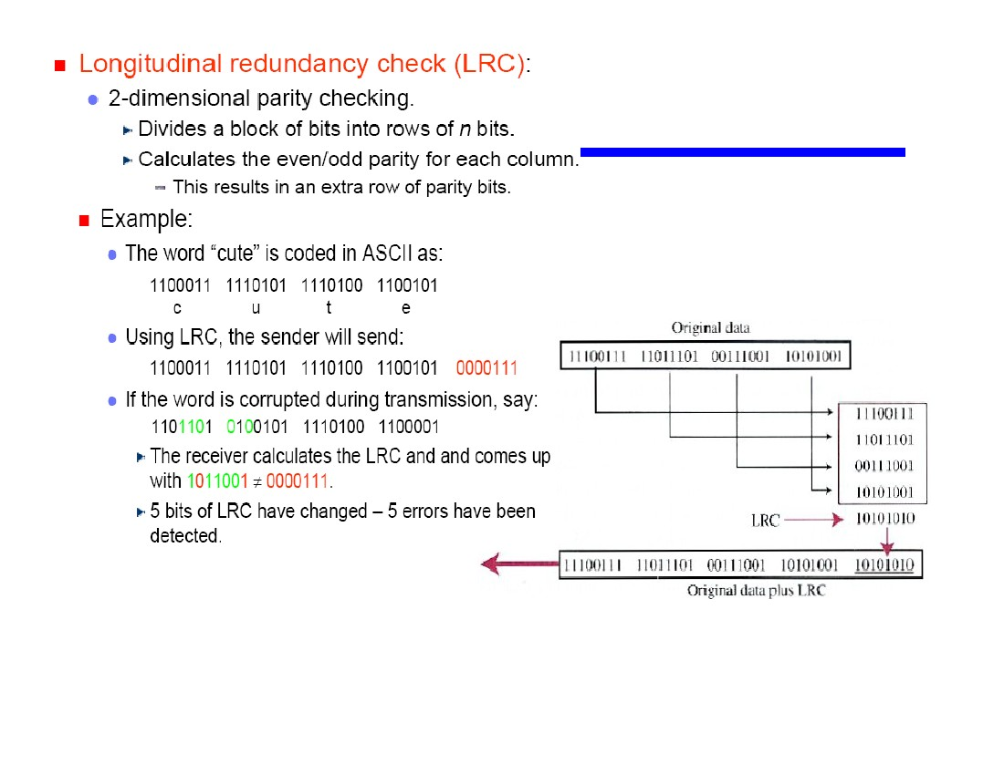
•Increases the likelihood of detecting burst errors.
•n bits LRC can detect a burst error of n bits.
•Errors may be undetected if:
•They occur in exactly the same positions.
•Have even number of errors in that position.
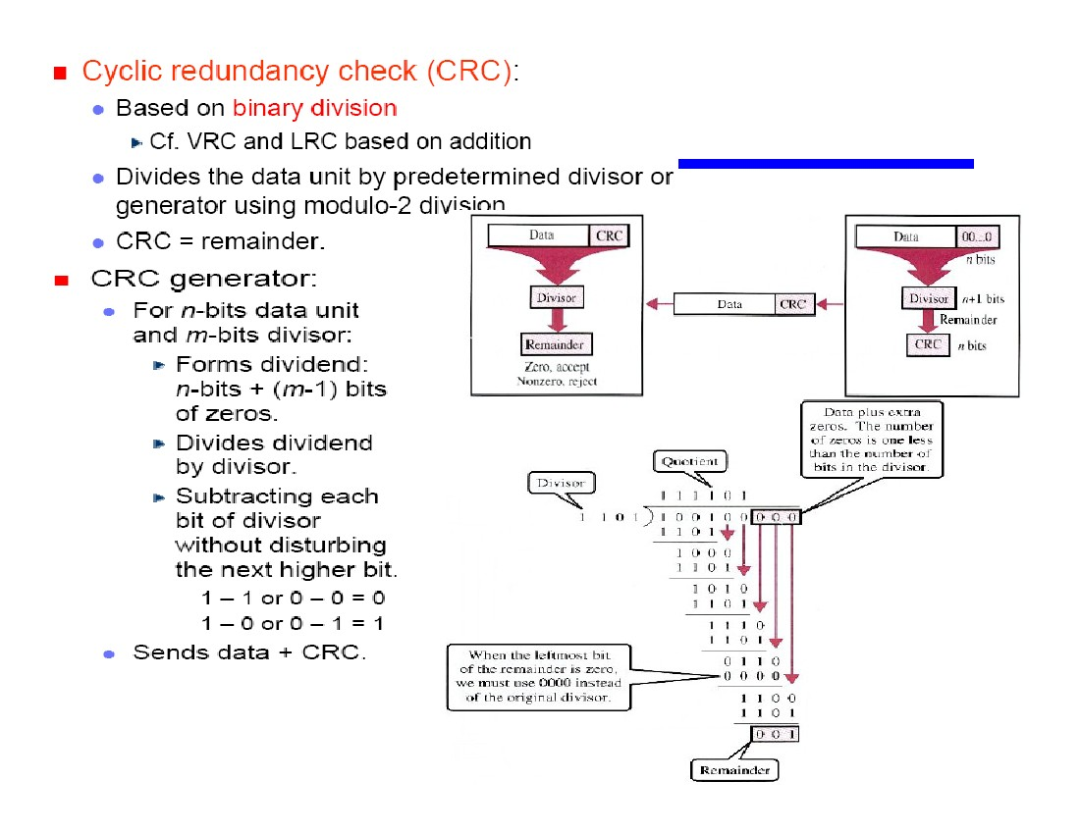

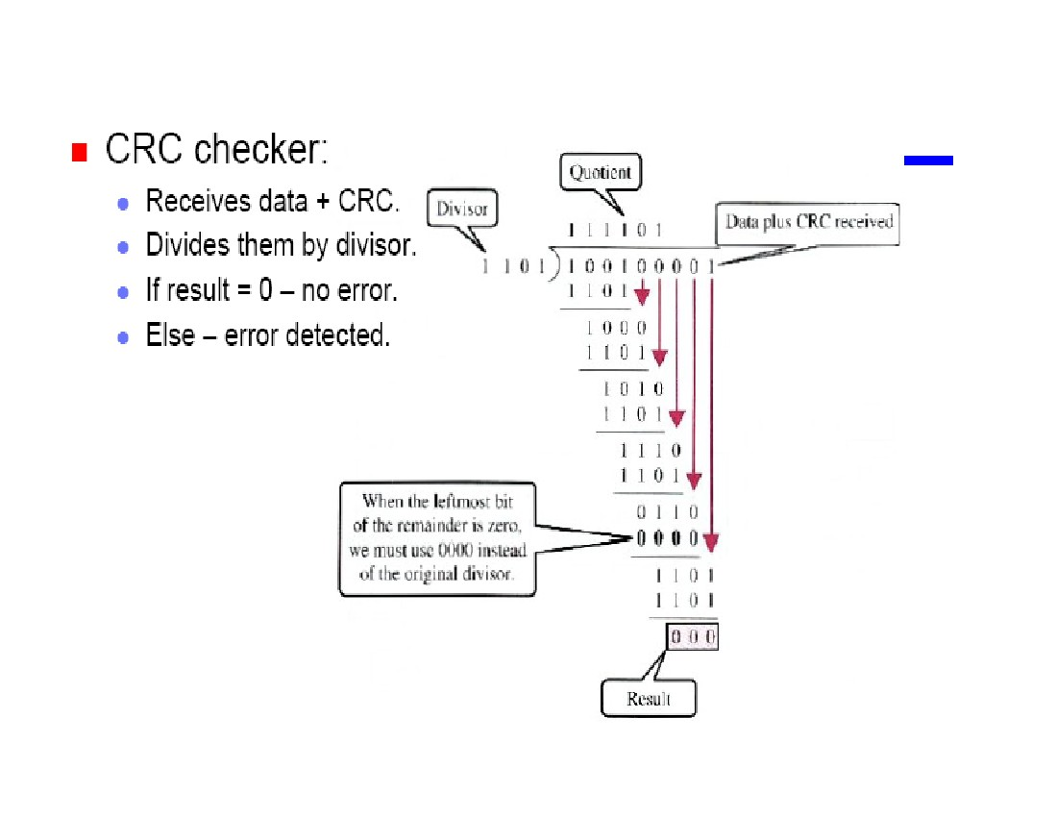
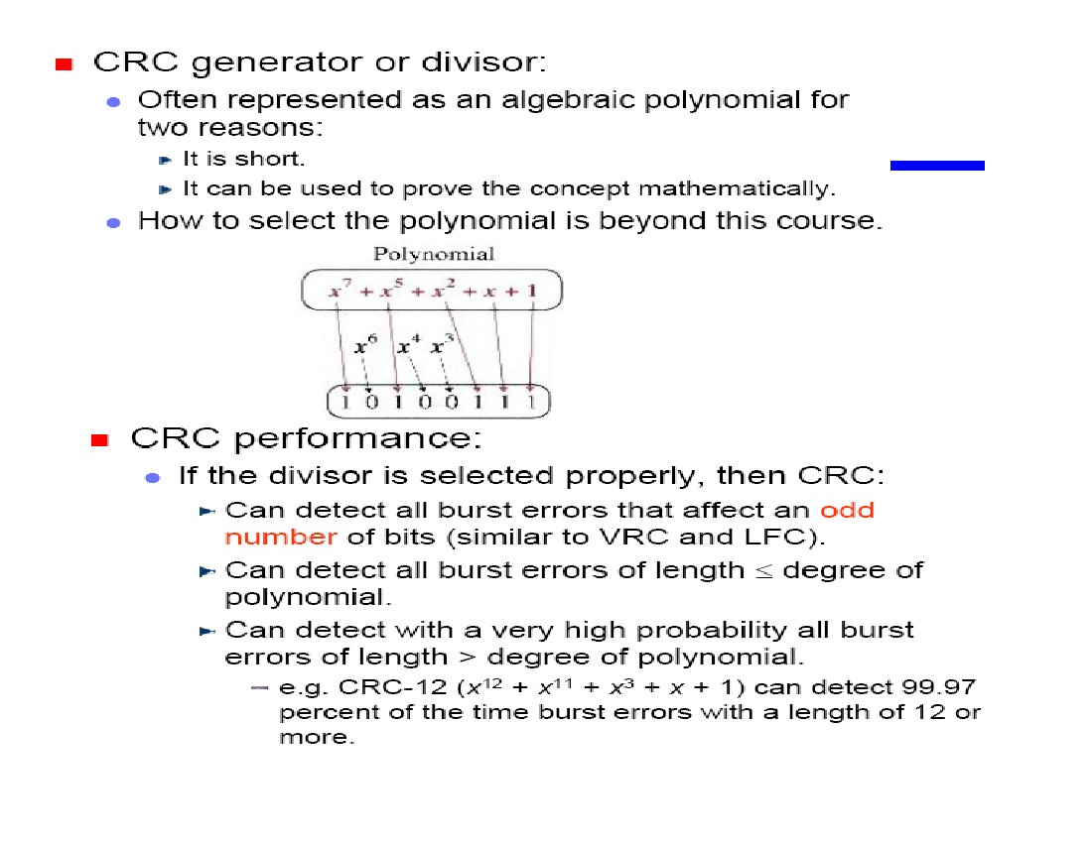
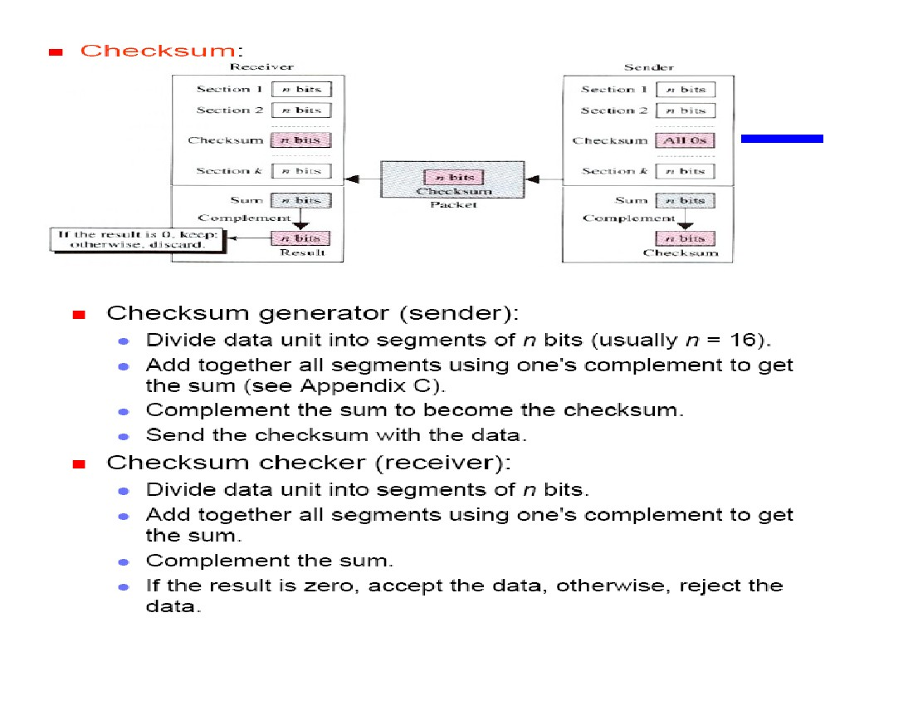
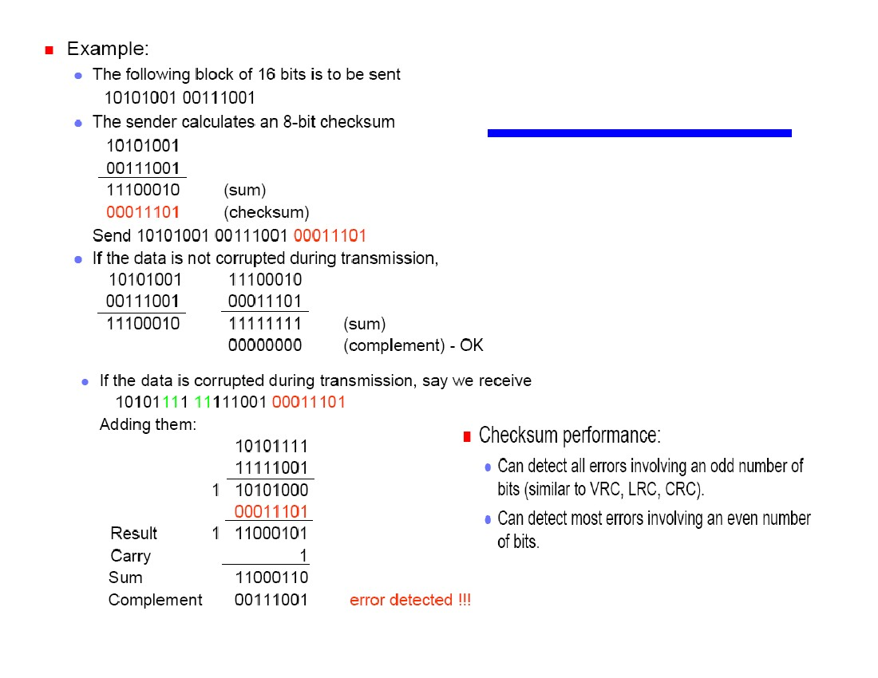
Idea: view message as a sequence
of 16-bit integers. Add these
integers together using 16-bit ones
complement arithmetic, and then
take the ones complement of the
result. That 16-bit number is the
checksum.

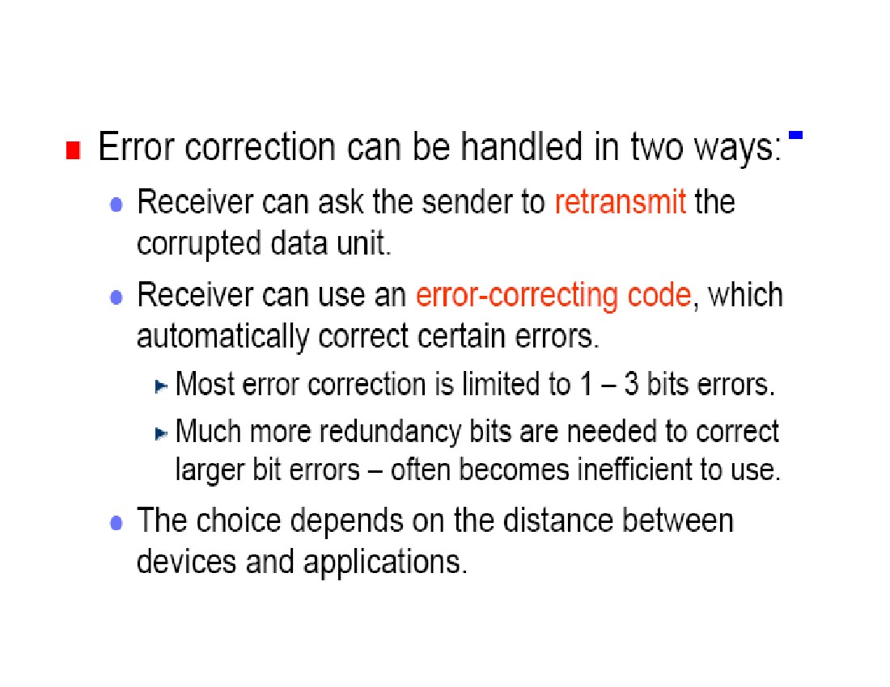
Error Correction

